Lecture 3,4 : Intro. to TRIZ  
Use the PPT 1 and some videos for intro. TRIZ.  
  
Later use PPT 2 for more examples and info. if needed, otherwise, PPT 1 can be enough.   
  
Use some of the examples as Case studies during Tut / Lab. session using TRIZ40.com site.

<https://www.youtube.com/watch?v=1uFWSk2W3Go>

[](https://www.youtube.com/embed/1uFWSk2W3Go?feature=oembed)

<https://www.youtube.com/watch?v=IDrdFIGzDUg>

[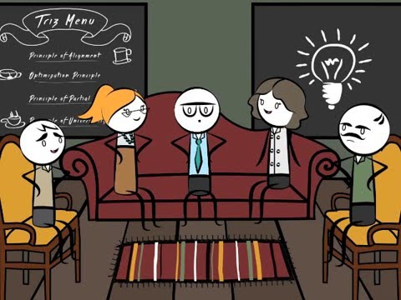](https://www.youtube.com/embed/IDrdFIGzDUg?feature=oembed)

<https://www.youtube.com/watch?v=y9DR4C6vPlA>

[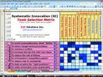](https://www.youtube.com/embed/y9DR4C6vPlA?feature=oembed)